**Practical – 3**

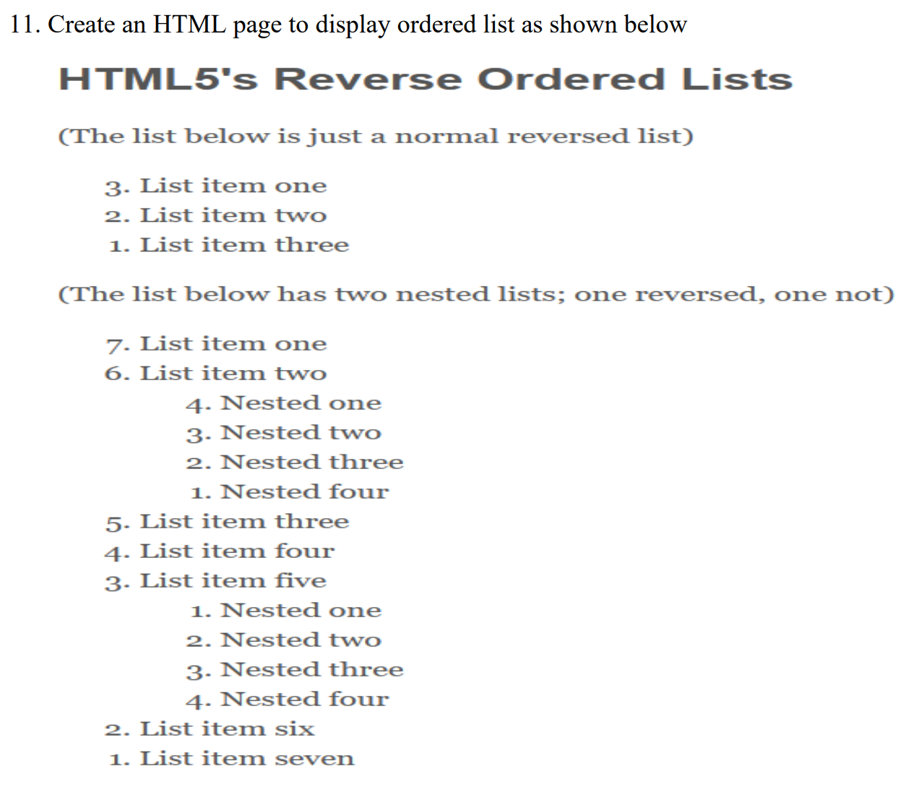

**HTML Code**

<!DOCTYPE html>

<html lang="en">

<head>

<meta charset="UTF-8">

<meta name="viewport" content="width=device-width, initial-scale=1.0">

<title>Rowspan & Colspan </title>

</head>

<body>

<h1>HTML5's Reverse Ordered Lists</h1>

<p>(This list below is just a normal reversed list)</p>

<ol type="1" reversed>

<li>List item one</li>

<li>List item two</li>

<li>List item three</li>

</ol>

<p>(This list below has two nested list; one reversed, one not)</p>

<ol type="1" reversed>

<li>List item one</li>

<li>List item two

<ol type="1" reversed>

<li>Nested one</li>

<li>Nested two</li>

<li>Nested three</li>

<li>Nested four</li>

</ol>

</li>

<li>List item three</li>

<li>List item four</li>

<li>List item five

<ol type="1">

<li>Nested one</li>

<li>Nested two</li>

<li>Nested Three</li>

<li>Nested Four</li>

</ol>

</li>

<li>List item six</li>

<li>List item seven</li>

</ol></body>

</html>

**Output**

